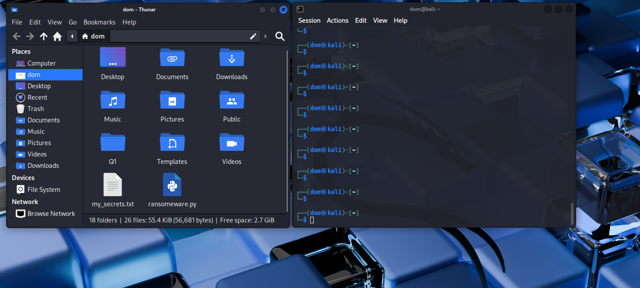
Part1: image of ransomware python file and my_secrets.txt file

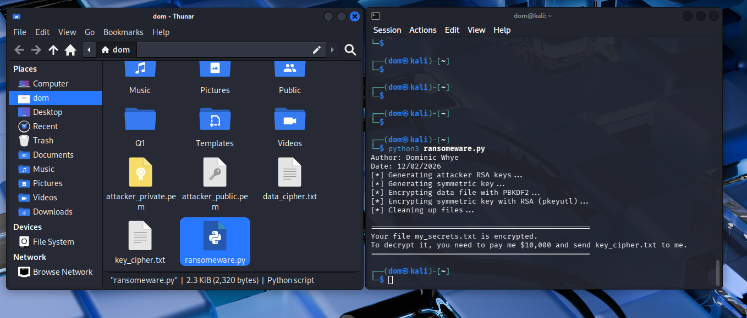
Part2: Executing ransomware file

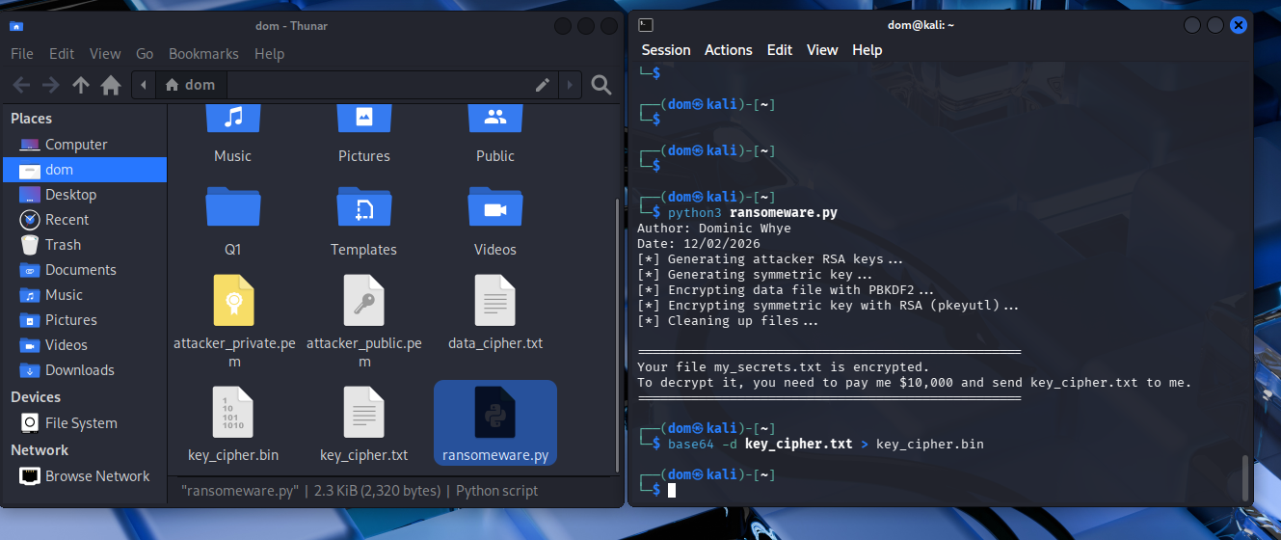
Part3: converting text file to binary

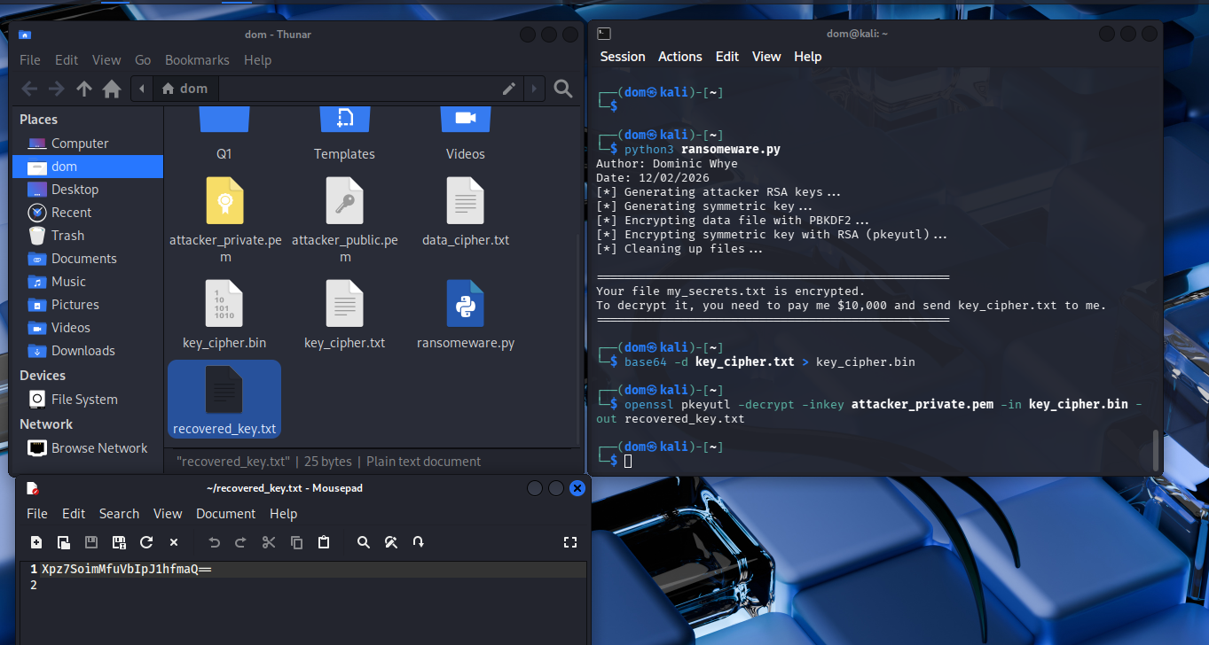
Part4: decrypting the key file

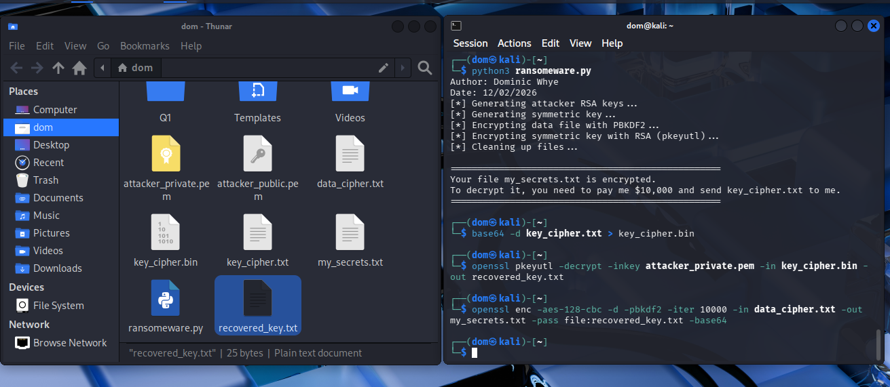

Part5: retrieving the my_secrets.txt file

